CaseManagement_Copying Case_Instance32_15-Jun-2018_07-40-28_AM_ValidatingCaseentitynavigation.png

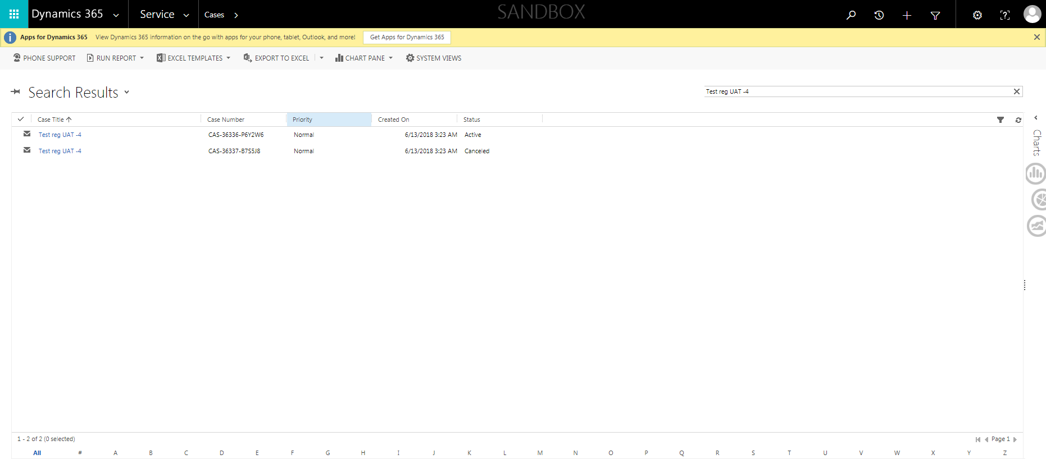

CaseManagement_Copying Case_Instance32_15-Jun-2018_07-40-37_AM_CopycaseVerifyStatusReason.png

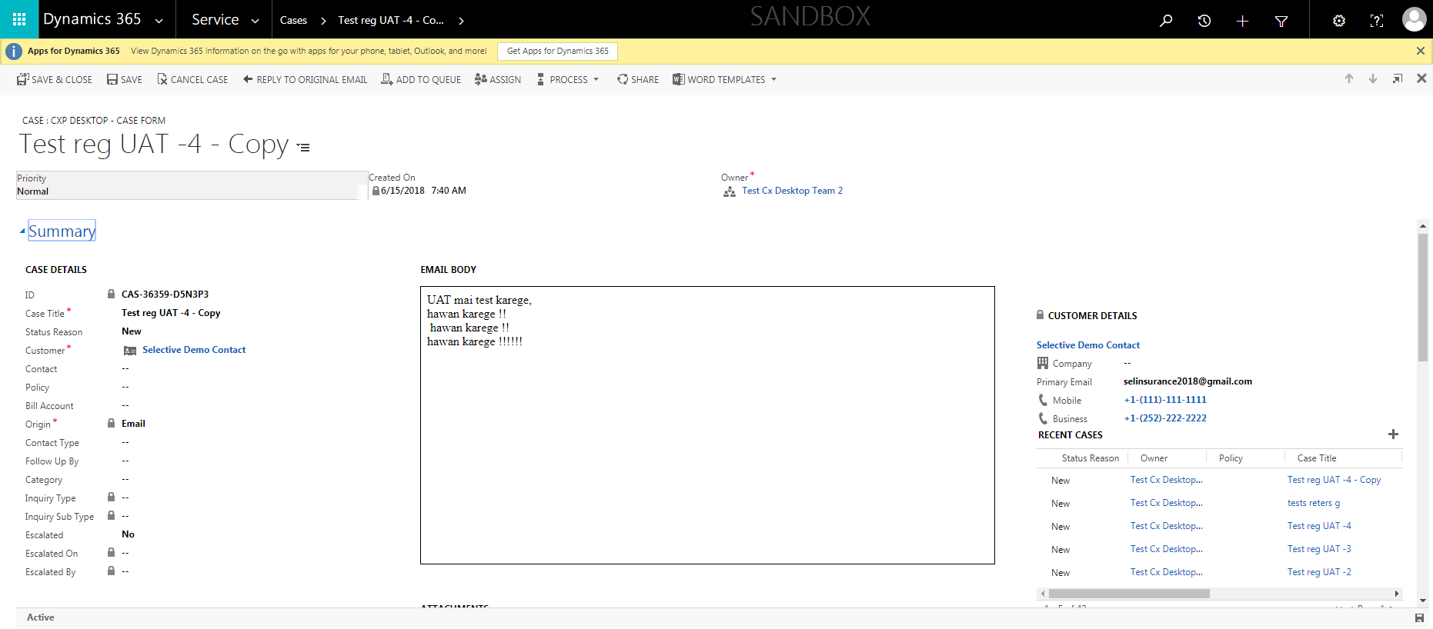

CaseManagement_Copying Case_Instance32_15-Jun-2018_07-40-35_AM_CopycaseVerifyCustomerName.png



CaseManagement_Copying Case_Instance32_15-Jun-2018_07-38-33_AM_SingleSignOn.png

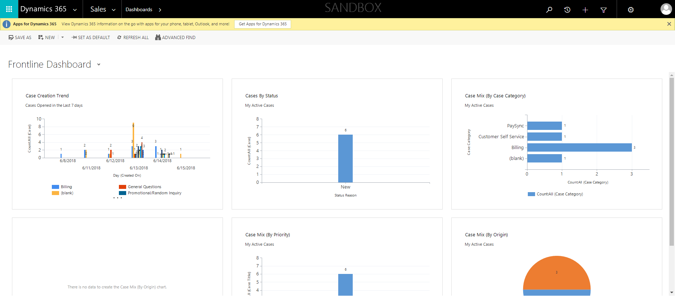

CaseManagement_Copying Case_Instance32_15-Jun-2018_07-40-35_AM_CopycaseVerifyOwner.png



CaseManagement_Copying Case_Instance32_15-Jun-2018_07-40-36_AM_CopycaseVerifyPriority.png



CaseManagement_Copying Case_Instance32_15-Jun-2018_07-40-36_AM_CopycaseVerifyTitle.png



CaseManagement_Copying Case_Instance32_15-Jun-2018_07-38-04_AM_EnterTextAction.png

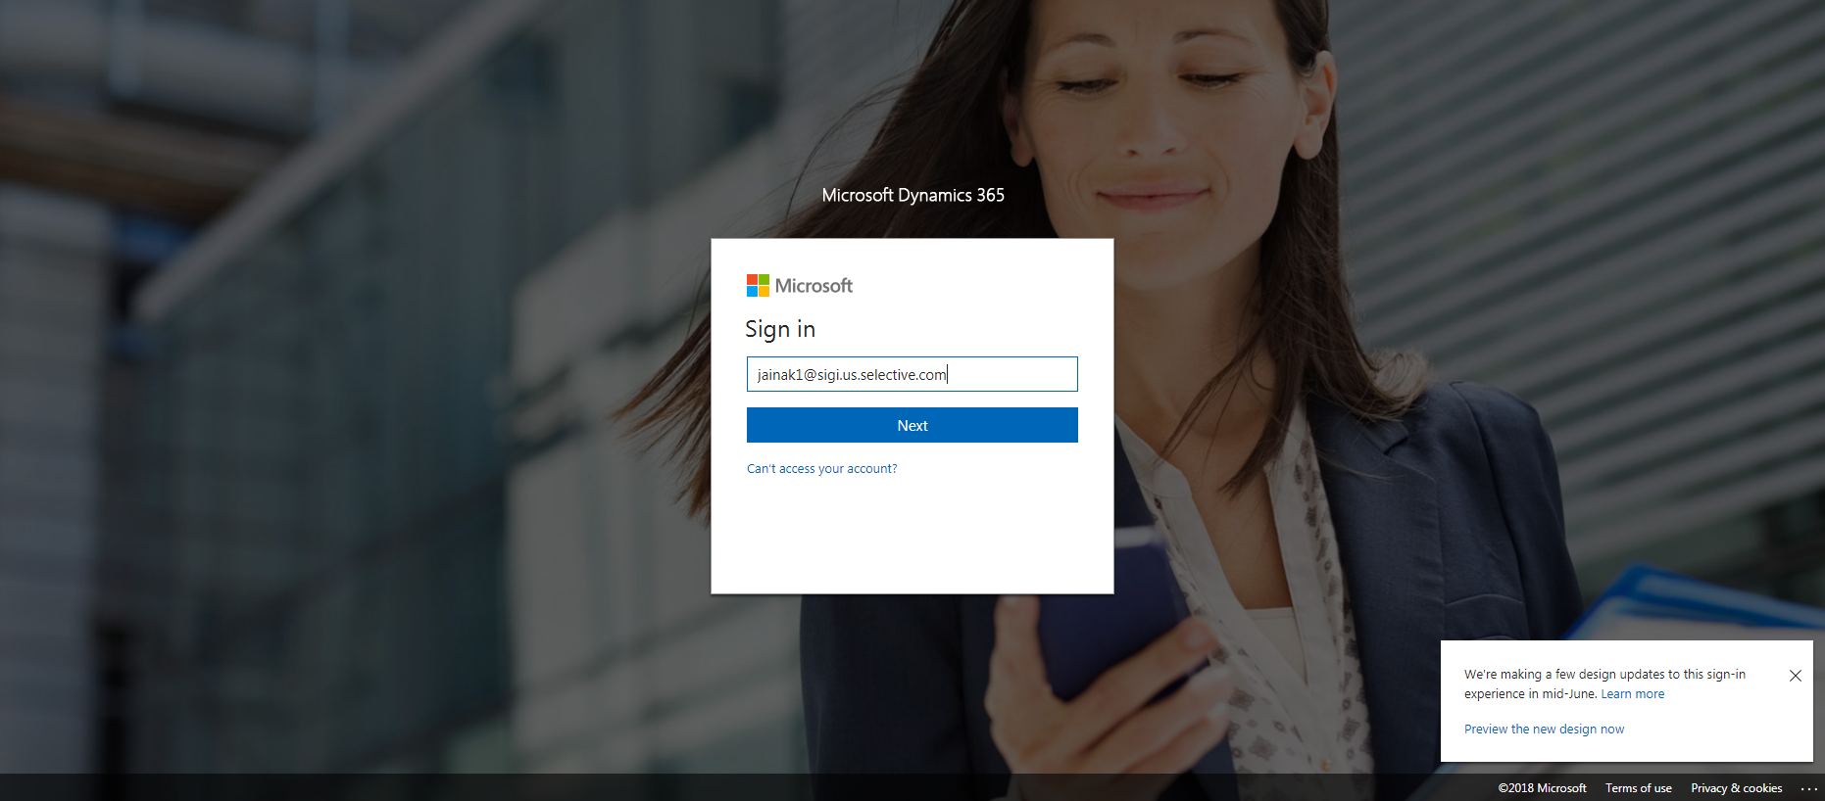

CaseManagement_Copying Case_Instance32_15-Jun-2018_07-40-24_AM_Copycase.png

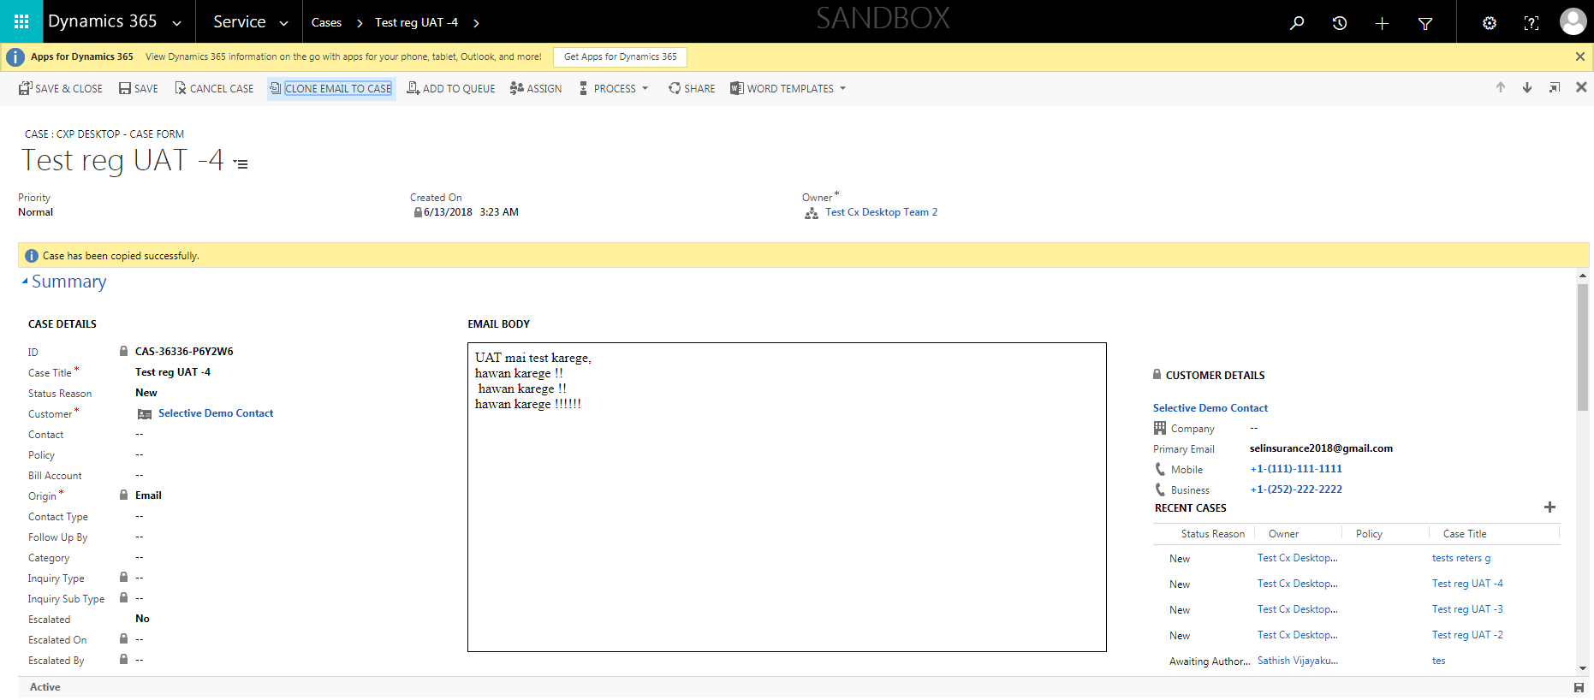

CaseManagement_Copying Case_Instance32_15-Jun-2018_07-38-06_AM_MouseClickActiononStaleElement.png

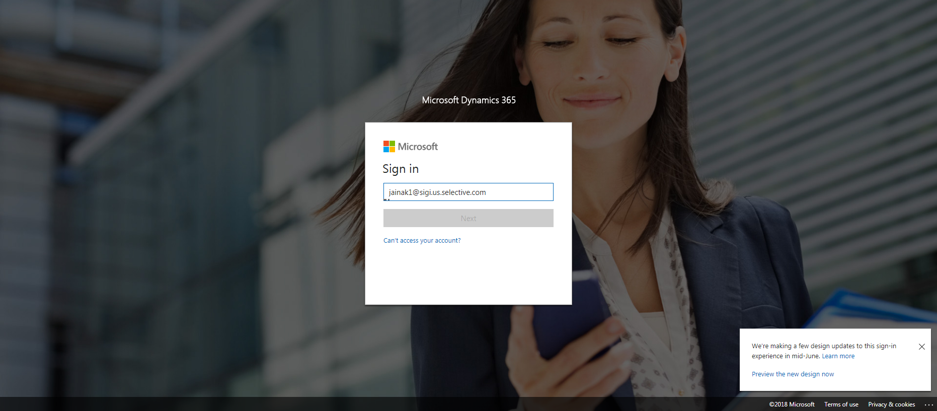

CaseManagement_Copying Case_Instance32_15-Jun-2018_07-40-37_AM_CopycaseVerifyOrigin.png



CaseManagement_Copying Case_Instance32_15-Jun-2018_07-38-03_AM_MouseClickActiononStaleElement.png

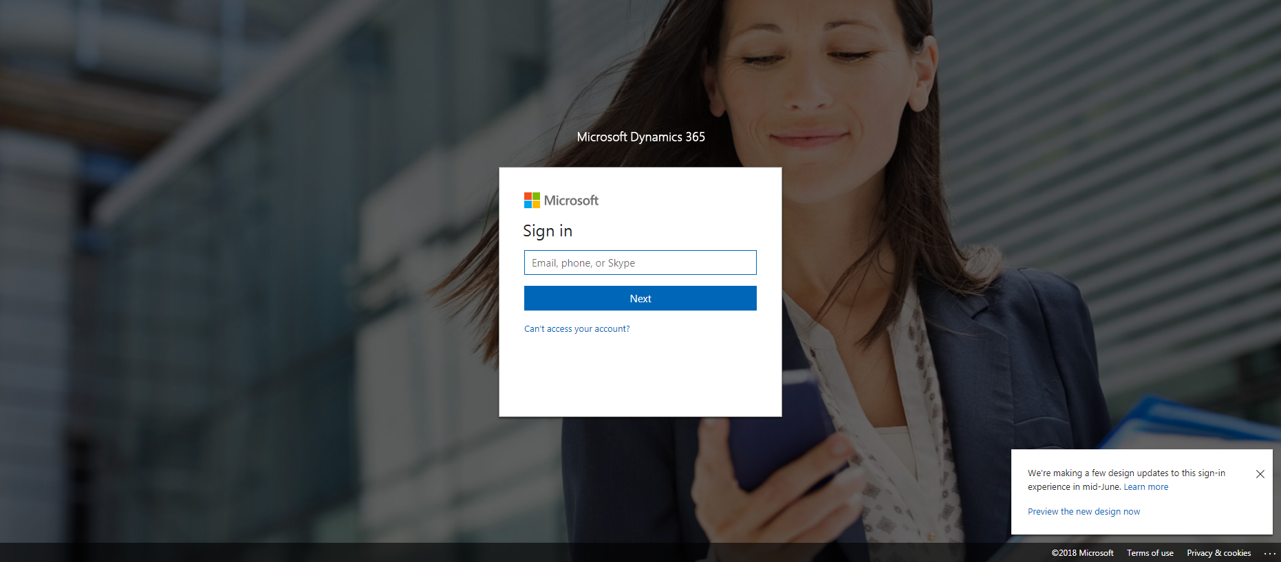

CaseManagement_Copying Case_Instance32_15-Jun-2018_07-40-03_AM_ValidatingCaseentitynavigation.png

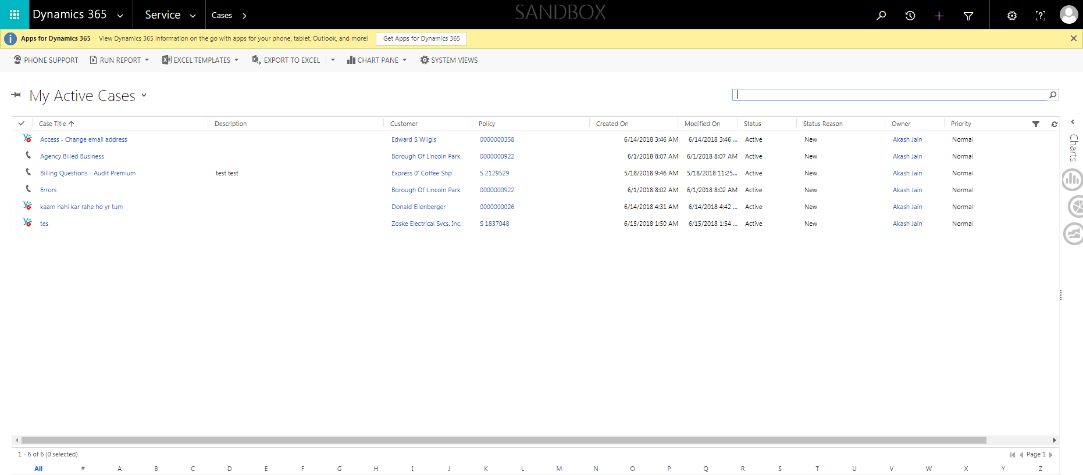

CaseManagement_Copying Case_Instance32_15-Jun-2018_07-40-31_AM_ValidatingCaseentitynavigation.png

